Project Report: Password Manager Application

By: Jaswanth Garikipati

KSU ID: 811227383

1. Introduction:

The Password Manager Application is a prominent solution for the increasing issues around password management in the digital realm. In this era of growing cyber threats, having a reliable, easy-to-use, and secure password management system is essential. This application streamlines the tedious password management procedure while prioritizing data protection. This study examines the architectural features of the program, with a focus on the security measures implemented to safeguard user data.

1. Architecture Overview:

The architecture of the program is made to guarantee a secure and seamless consumer revel in. To create a responsive and user-friendly interface, HTML, CSS, and JavaScript are used in the frontend. The backend manages server-aspect operations and database interactions. It's powered by using SQLAlchemy and Flask. In order to acquire the undertaking's targets of simplicity, ease of deployment, and platform compatibility, SQLite changed into selected as the database device.

* 1. Frontend:

The application's frontend is constructed with HTML for structure, CSS for styling, and JavaScript for interactivity. It provides a user-friendly interface and employs responsive design ideas for a variety of devices.

* 1. Backend:

The Flask framework is utilized by the Python-coded backend. Creating internet apps, managing user requests, and interacting with databases are all made simpler by means of Flask. SQLAlchemy is an Object-Relational Mapping (ORM) device used for database operations.

* 1. Database:

SQLite is used as the database system due of its ease of use and compatibility with Flask applications. To improve security, the database holds encrypted passwords.

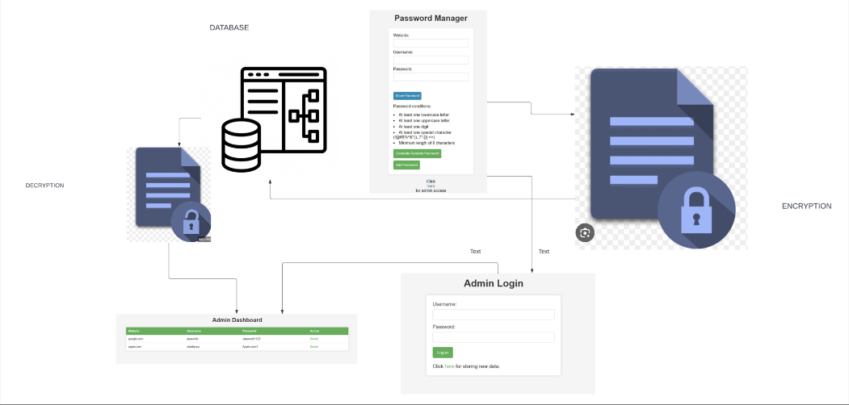

Fig. 1: Architecture Diagram

1. Libraries Used:
2. Flask: The fundamental web framework for Python web application development that manages HTTP requests, responses, and routing.
3. Flask-WTF: Combines WTForms and Flask, making it easier to create and manage web forms within the application.
4. WTForms: An adaptable Python library for forms validation and rendering that simplifies the definition, verification, and rendering of forms in online applications.
5. Flask-SQLAlchemy: Offers a handy interface for SQLAlchemy, an Object-Relational Mapping (ORM) library that is strong and adaptable, to communicate with databases.
6. Flash: A Flask feature that lets users see messages and receive feedback on things like successful logins and error messages.
7. Enhances the security of user-related functionalities by managing user sessions and authentication in Flask applications with Flask-Login
8. Jinja2: A handy tool for creating web pages, this template engine is used by Flask to render dynamic content in HTML files.
9. Click: A Python package that facilitates the creation of CLIs; frequently used in Flask applications to provide custom management commands.
10. Security Measures:
11. Encryption:

The Fernet symmetric encryption algorithm is used to encrypt passwords. This guarantees that the passwords are safe even if the database is hacked.

1. Secure Password Generation:

A feature of the application that meets certain requirements allows it to generate strong, random passwords. It encourages the use of strong passwords.

1. Session Management:

Session management is handled by Flask-Login, which guarantees safe user authorization and authentication. It protects against unwanted access to private features.

1. Input Validation:

The application makes use of each the front-give up and lower back-give up validation of consumer enter to shield in opposition to commonplace vulnerabilities like SQL injection and Cross-Site Scripting (XSS).

1. Potential Vulnerabilities and Mitigations:

Even with the application's strong security features, proactive vulnerability detection is still necessary. The implementation makes use of parameterized queries and SQLAlchemy's Object-Relational Mapping (ORM) features to protect against SQL injection attacks. Strict user input sanitation procedures and Flask's built-in security features help to minimize Cross-Site Scripting (XSS) vulnerabilities. Strengthening defenses against session fixation issues is the integration of Flask-Login's session protection features.

1. SQL Injection:

Vulnerability: Inadequate input validation may make the application susceptible to SQL injection attacks.

Mitigation: By using parameterized queries and SQLAlchemy's ORM features, SQL injection attacks can be prevented.

1. Cross-site Scripting (XSS):

Vulnerability: XSS attacks can result from improper handling of user inputs.

Mitigation: To reduce the risk of cross-site scripting attacks, user inputs are cleaned up and Flask's inherent security features are used.

1. Session Fixation:

Vulnerability: If session management is not sufficiently secured, session fixation attacks could happen.

Mitigation: To guard against session fixation attacks, Flask-Login uses built-in security features like session protection.

1. Insecure Passwords:

Vulnerability: Passwords chosen by users may be weak and vulnerable to brute-force attacks.

Mitigation: By informing users about the need for strong passwords, the application promotes the creation of intricate and one-of-a-kind passwords.

1. Conclusion:

The Password Manager Application uses a secure architecture that prioritizes strong session management, encryption, and secure password creation. By using parameterized queries, thorough input validation, and other security best practices, potential vulnerabilities are addressed. The application's resistance to changing threats will need to be maintained through regular security audits and updates.

To sum up, the Password Manager Application seeks to give users a safe space in which to efficiently manage their passwords. The application aims to protect user data integrity and confidentiality by adhering to accepted security guidelines and fixing any vulnerabilities.

1. Future Enhancements:

Future developments for the Password Manager Application may include biometric authentication, providing users with an extra degree of protection. Maintaining the application's security posture will require a continuous dedication to proactive monitoring, frequent security audits, and user education programs. Taking advantage of the project's open-source nature may encourage community contributions, opening the door to increased security resilience and capability. The project's roadmap anticipates a changing future while keeping up with new paradigms in cybersecurity and emerging technologies.